**Frequency bands**

|  |  |  |
| --- | --- | --- |
| ISM Bands (Industrial, Scientific, Medical) | ISM Bands are not allocated for specific uses, and are available for unlicensed use. TV and FM radio have their own frequency allocations | 902-928 MHz  2.4-2.5 GHz  5.728-5.875 GHz  24 - 24.25 GHz |

**Shannon Capacity**

Describes the capacity of a noisy channel

$C=B\log_{2}\left(1+SNR\right)$

* $C$– Data rate
* $B$– Bandwidth available
* $SNR$**–** Signal-to-Noise Ratio, Lower SNR 🡪 Poorer propagation

Noise is naturally higher with wider bandwidth. Higher frequencies have poorer propagation characteristics, resulting in weaker signal.

**Gain (dBi) and Directivity**

Directed antenna such as Yagi, parabolic antennas have directivity.

Directivity/Gain is measured relative to isotropic antennas (perfect sphere)

Isotropic antennas have a relative gain of 1, or 0 dBi

$G=\frac{4πA_{e}}{λ^{2}}=\frac{4πf^{2}A_{e}}{c^{2}}$

* G = Antenna gain, $A_{e}$ = effective area
* $f$ = carrier frequency, $c$ = $3×{10}^{8}$ m/s, $λ$ =carrier wavelength

Higher frequencies have better directivity characteristics, but has higher path-loss

**Friis Path-loss equation**

$P_{r}=G_{t}G_{r}{\left(\frac{c}{4πdf}\right)}^{α}P_{t}$

Note: the free space path loss is derived from the Friis path loss formula and is expressed in decibels.

It assumes a path-loss component $α$ of 2, which is free space.

$FSPL=P_{t}-P_{r}=20\log_{10}\left(d\right)+20\log_{10}\left(f\right)+20\log_{10}\left(\frac{4π}{c}\right)-G_{t}-G_{r}$

**Log/Decibel calculation**

$$10\log_{10}{x}$$

**IoT Devices**

* Computation and storage, sensing and actuation, power, wireless connectivity

**Actuators:** Devices that modify a physical quantity

**Sensor**: Devices that measures a physical quantity

* Passive sensing vs Active sensing (emitting something to allow sensing)
* Electrical signals involves modifying one or more variable in Ohm’s law $V=IR$

**Microprocessor** – CPU and pins

**Microcontroller** – Microprocessor + memory + Peripherals (specialized hardware units such as ADC, oscillators, etc.)

**SoC** – Microcontroller + extensive peripherals (radios, accelerator chips, etc.)

**Battery Life and Power Consumption**

**Ampere**: Amount of charge flowing through a point per second

**Voltage**: SI unit of electromotive force

**Power (Watts)**: Voltage $×$ Ampere **Energy**: Power $×$ Time

**Watt-hour** (Wh):

* Amount of energy equivalent to one watt of power spent for one hour of time

**Ampere-hour** (Ah):

* Amount of electrical charge transferred by a steady current of 1A for 1 hour.

**Power considerations when choosing wireless technology**

**Duty cycle** – Time and power spent idling vs receiving vs transmitting.

**State switching time** – Ability to switch between states quickly

**Data rate, range –** Different technology supports different data rates and range

**Form factor** – small antenna may require higher transmission/receiving frequency

**Peak current draw** – some wireless technology may have higher peak current draw compared to the rated battery current.

**Networking capabilities** – Some technologies can be arranged into specific topologies

**Distance Ranging and Localization**

Localization performed relative to some anchor wireless device

* Location can be deduced in 2D plane using trilateration with 3 non-colinear devices, or 3D space with 4 non-coplanar devices
* Requires measurement of distance between these nodes (**distance ranging**) or **angle of arrival**

**Distance ranging** can be performed using several techniques:

* **RSSI (Received Signal Strength Indicator):** 
  + In theory, RSSI varies with $\frac{1}{d^{α}}$, where $α$ is the path-loss component
  + In practice, RSSI measurements contain noise due to radio wave travelling through different mediums, multipath arrival, orientation, and obstacles
* **Time of Flight/Time of Arrival:** 
  + Requires clock synchronization of sending and receiving device.
  + Requires high clock accuracy/granularity depending on signal speed.
    - meter level accuracy for speed of light = 1/c = ~3 nanoseconds
    - meter level accuracy for sound = 1/330 = ~3 microseconds
* **Time Distance of Arrival:**
  + Send a light and sound signal at the same time to the target device.
  + Time difference of arrival between these 2 pulses can be used to determine the distance between the two devices

**Radio Tomographic Imaging**

* Uses attenuation caused by object to identify its location in space.
* Directional RTI offers much better estimate than mean/variance/multi-channel RTI with omnidirectional antennas
* Any attenuation of signal is amplified due to gain of directional antenna, allowing for more accurate measurements. Any obstructions outside area of interest have diminished impacts too.

**Global Positioning System**

* Trilateration using ToF from at least 4 satellites, all in well-known, medium earth orbits(20000km) with very stable clocks
* Placed such that 4 are in view everywhere, always. 31 in orbit as of Nov 2020
* GPS frequency: 1227.60 MHz and 1575.42 MHz, 10-15 MHz bandwidth, Binary Phase Shift Keying modulation
* Tx Power: 25 watts (44dBm), Rx Sensitivity (-140 to -160 dBm) (50bps data rate)
* ~200 dBm link budget

To calculate location and clock time of the GPS signal, we have the following variables:

* $t_{i}^{'}$: local timestamp of message reception
* $t_{i}$: received timestamp according to satellite $i$
* $e$: error between local timestamp and satellite timestamp (assuming all satellites are very accurate and have the same time)
* $d_{i}$: distance between receiver and satellite $i$
* $c$: speed of light
* $x_{i},y_{i},z_{i}$: Location/orbit of satellite

Listening for up to 30s gets $t_{i}$ and $x_{i},y_{i},z_{i}$

* also known as ephemeris, valid up to 4 hours

Listening for 12.5 minutes gets all satellite’s positions

* known as almanac, valid up to 2 weeks

A set of 4 equations can be formed and solved using $i∈\{1,2,3,4\}$ to receive $e, x,y,z$. The $x,y,z$ coordinates can be used to determine location, while $e$ is used to synchronize our local clocks with GPS.

$t_{i}^{'}=t_{i}+e+\frac{d_{i}}{c}$, where $d_{i}=\sqrt{{\left(x-x_{i}\right)}^{2}+{\left(y-y_{i}\right)}^{2}+{\left(z-z_{i}\right)}^{2}}$

**Assisted GPS**

* download almanac from the internet, or
* use cell towers to provide coarse location, and let devices know which satellites are overhead

**Wireless Fingerprinting**

* Send out a device to map the RSSI of a signal emitted by a fixed transmitter (such as a router, cell tower, etc.)
* Record measurements into database, and look up current signal strength for current location
* Multiple RSSI belonging to different transmitter can be used to enable higher accuracy
* **Challenges**: Manually take measurements at each location, signal strength affected by changes in environment, need to periodically remeasure, measurements can vary between devices (different antenna, phone cases, how you hold it, etc.)

**Ultra-Wide Band**

* Uses large bandwidth to send data packets in a much shorter time 🡪 shorter RF pulse
* Reduce the effect caused by multipath signals and smearing of signal, allowing more accurate TDoA measurements

**Ultrasound**

* Use sound instead of radiowaves, easier to get high-accuracy results
* Disadvantage: more energy to transmit, shorter range, slower update rate, pets can hear it…

**Inertial navigation**

* Integrate acceleration to get position. Errors in position are squared.
* Accurate over short distances, can be used to augment other systems

**ARKit**

* Leverage smartphone cameras to build augmented reality map for positioning

**Medium Access Control**

Wireless communication is inherently broadcast in nature. Signals must compete with other signals in the same frequency band to get seen. To determine who to send, we can:

* Raise hands 🡪 out-of-band communication
* Wait until it is quiet for some time 🡪 carrier sense multiple access
* Strict turn order 🡪 time division multiple access
* Just speak and hope it works 🡪 ALOHA
* Everyone speak at different tones 🡪 frequency division multiple access

**Taxonomy of Multiple access protocols**

**Random-access protocols (collision reduction, manage retransmission)**

* ALOHA, CSMA/CD , CSMA/CA

**Controlled-access protocols (prevents collision)**

* Reservation, Polling, Token Passing

**Channelization protocols (prevents collision)**

* FDMA, TDMA, CDMA

**Random-access protocols**

**ALOHA**: Just send whenever you feel like it

* **Used by** BLE adverts, Unlicensed LPWANs such as Sigfox, LoRaWAN

**Slotted ALOHA**: If needed, send at the start of a slot, and transmission is as long as slot (size of a frame).

* Minimal overhead, low transmission delay if link contention is low
* High rates of collision, low channel utilization rate of 18.4% and 36.8% each

**CSMA**: Carrier Sense Multiple Access

* First sense if anyone is sending on medium
* Send a frame once the channel is clear, then wait for ACK. If no ACK, assume collision and retransmit after some random interval.
* Much better channel utilization than ALOHA, higher throughput.

**CSMA/CD**: Carrier Sense Multiple Access/Collision Detection

* Transmit and receive simultaneously. If something is received, then terminate transmission immediately and resend after random interval
* Cannot be used by wireless technology since it requires multiple antennas to receive and transmit simultaneously.
* Transmitting signal will also drown out receive signal, causing it to be difficult to detect any incoming signal.

**CSMA/CA**: Carrier Sense Multiple Access/Collision Avoidance

* If channel is determined to be busy, defer transmission for random interval (versus immediately sending once the channel is clear).
* Send if channel not busy, and wait for ACK, if not, assume collision and begin exponential backoff and retransmit.
* **Used by WiFi**

**Hidden Terminal Problem** – 2 Transmitting devices may not see each other, but the receiving device can see both transmitters. This causes a collision seen only by the receiver.

**CSMA with RTS/CTS**

* When channel is idle, transmitter sends a short Request To Send (RTS)
* Receiver will send CTS to only 1 node at a time
* RTS collisions are faster and less wasteful than hidden terminal collisions
* Downside: overhead is high for waiting for CTS when contention is low (essentially 2x 2-way latency to send 1 packet)

**Exposed Terminal Problem** – 2nd transmitter does not receive CTS and is also prevented from sending to an unrelated receiver because it will cause collision with the first.

**Fairness**

Transmitting using CSMA is not fair since each node gets the send roughly the same number of frames over time. For nodes with faster transmission rate, the time the node takes on the spectrum is much less than a slow transmitting node. A much better notion of fairness is to allocate each node with the same amount of time slot.

**Capture Effect**

Collision does not always lead to packet loss. If a receiver hears from two or more stations and the signal from one station is much stronger than the rest, the receiver can receive the signal correctly from the stronger station.

**Controlled-access Protocols**

**Reservation**

A station needs to make a reservation before sending data

* Time is divided into reservation and data slots
* Reservation frame precedes the data frames sent
* System is efficient if many data frames are sent after one reservation

**Select/Polling**

* One primary and many secondary stations
* Select mode: Primary station selects one secondary station to send to
* Poll mode: Primary station polls from the list of secondary stations and secondary sends only when polled.
* Also known as Point coordination function in iEEE 802.11 standard
* No collision since channel access is controlled by primary station.
* Supports interactive traffic, e.g. VoIP

**Token Passing**

**Channelization Protocols**

**FDMA – Frequency Division Multiple Access**

* Splits transmission in frequency. Different carrier frequencies are independent.

**TDMA – Time Division Multiple Access**

* Splits transmission in time. Devices share the same channel, but are allocated to different time slots of fixed length.
* Priority system is possible by allocating uneven amounts of slots among devices
* Requires synchronization between devices
  + Often devices must listen periodically to resynchronize
  + Less efficient of use of slots can reduce need for synchronization
    - E.g. Large guard window by sending a 1s transmission in a 1.5s slot
* **Used by:** BLE connection mode, Cellular LPWANs: LTE-M and NB-IoT

In practice, TDMA and FDMA are combined. Full duplex communication is also made possible by sharing of channel using Frequency/Time Division Duplex

**Pros of “static allocation”**

* Resource is always available, performance is guaranteed.
* No interference from other users

**Cons**

* Inefficient if resources are not utilized. Resources cannot be used by others.
* Slow to adjust to traffic demand changes.

**OFDM – Orthogonal Frequency Division Multiplexing**

* **Orthogonality** – Signal is sent when other signals are 0 with respect to current signal.
* Data is divided into many subcarriers with smaller spectrum. Data is sent on the same frequency, but when all other signals are null or 0.

* Robust to selective fading.
* Overcomes inter-symbol interference because data-rate per subcarrier is low
* Applications: IEEE 802.11a,g,n, ac, LTE/5G, Digital radio and TV broadcast

**General model for spread spectrum techniques**

**FHSS**

* Signals are transmitted across many frequency channels.
* Increases resistance to natural interference, jamming and detection

* **Used by**: Original version of IEEE802.11 in 1977

**CDMA – Code division multiple access**

* **Synchronous CDMA**
  + Uses orthogonal codes to encode signal when sending from base station to mobile
* **Asynchronous CDMA**
  + Uses pseudorandom codes to encode signal when sending from mobile to base station
  + Pseudorandom codes are used since it is impossible to precisely coordinate different mobile-to-base links.
  + **Correlation property**: If a period of the sequence is compared term by term with any shift, the number of terms that are the same differs from those that are different by at most 1.
* **Used by**: Cellular (2G CDMA (IS-95), 3G networks)

**DSSS – Direct sequence spread spectrum**

* **Used by**: 802.11b, 2.4Ghz, DSSS/CCK at 5.5 and 11Mbps

**Medium access control for IoT**

* For traditional MAC, we want **Low Latency, High Utilization, Fairness**
* For IoT devices, we want energy efficient MAC protocols since:
  + Power consumption is a key consideration for most IoT devices
  + Most sensor applications have low channel utilization
* Main sources of energy consumption in any contention-based MAC protocol:
  + Overhearing
  + Control packet overhead
  + Data transmission/reception
  + Idle listening

The first 3 occurs only when there is transmission, idle listening occurs even when there is no traffic.

**B-MAC**

* Asynchronous MAC protocol based on preamble sampling. Earliest MAC protocols for IoT.
* A node turns on periodically to check for activity, if it receives a packet, it stays awake until data is received, else it goes back to sleep after a timeout.
* Idle listening occurs when the node samples the channel and finds no activity
* To ensure successful reception, the **preamble length must be equal to or much longer than the channel sampling interval**
  + If the channel is checked every 100ms, preamble must be at least 100ms

**X-MAC**

* Improvement over B-MAC
  + Transmitter: Remove long continuous preamble
  + Receiver: Reduce long average waiting period until transmission begin
* Transmitter sends many “probes” with gaps between probes, each probe contains address of intended receiver
* Receiver receives and check data embedded in probe, sends ACK if it is the intended recipient during the gap period between probes.
* Sender receives ACK and transmit DATA, receiver replies with ACK to complete transfer.

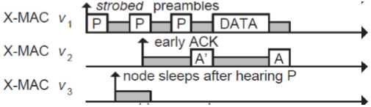

**CONTIKI-MAC**

* MAC protocol implemented in the Contiki OS

* : the interval between each packet transmission
* $t_{r}$: the time required for a stable RSSI, needed for a stable **CCA** indication
* $t_{c}$: the interval between each clear channel assessment (**CCA**)
* $t_{a}$: the time between receiving a packet and sending the ACK packet
* $t_{d}$: the time required for successfully detecting an ACK from the receiver

**Receiver-Initiated MAC (RI-MAC)**

* Transmitter wakes up and listens for a period of $t_{p}$
* Receiver wakes up ever $t_{p}$ and sends a small packet to announce its presence
* Transmitter initiates transmission if the “right” receiver wakes up
* **Pros**: Less transmission and hence less collision, may consume less energy

**Synchronous MAC (S-MAC)**

* Let all nodes wake up at the same time
* Need to synchronize schedule of all nodes
* Initially, nodes are deployed to start after a random time interval
* The node whose timer expires first is the synchronizer
* Boundary nodes adopt multiple schedule

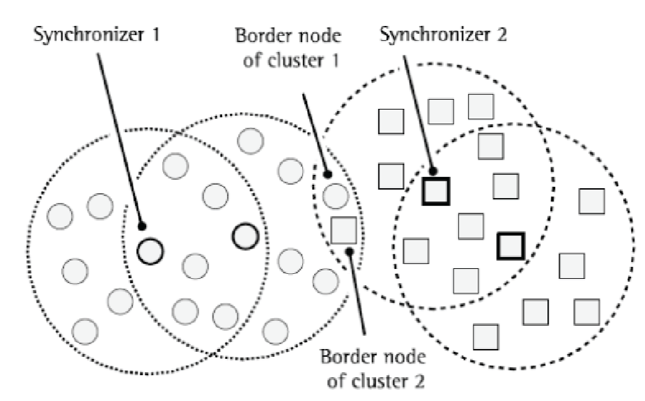

**Node Discovery**

**Synchronous neighbor discovery**

* All nodes are synchronized to the same clock/time
* Nodes wake up periodically at same time to transmit/receive packets
* Node A discovers Node B when it hears a transmission from node B
* **Drawbacks**
  + clock synchronization is expensive and periodic resynchronization will be needed to correct for clock drift over time
  + As all nodes wake up at the same time to transmit/receive, collision may increase if too many nodes transmit simultaneously
* **Synchronous discovery with asymmetric nodes**
  + Some nodes are more powerful and is always “ON”
  + A mobile associated with an AP wants to conserve energy by sleeping – how does the mobile device know there is data from the AP if it is in sleep state?
  + When a mobile device enters **Power Save Mode**, it informs the AP and goes to sleep.
  + Any packets arriving at the AP for the mobile device is buffered at the AP
  + The AP sends a beacon frame after every fixed time interval to inform the device in PSM about incoming packets
  + Device in PSM wakes up periodically to listen to beacon frames and switches to active state if there are incoming packets meant for it.

**Asynchronous neighbor discovery**

* Challenges: No time synchronization, all nodes are resource constrained

**Birthday Protocol**

* + Divide time into time slots and each device randomly picks slots to wake up.
  + Let $\overline{p}(n)$   denote the probability that all n birthdays are different. Then $p\left(n\right)$ denotes the probability that at least one pair of birthdays are the same.

|   |

* + Let two nodes randomly choose to wakeup $k$ time slots out of a total of $n$ slots, what is the probability of that they wakeup at the same slot at least once? $Q\left(n,k\right)=1-\frac{ _{n-k}C_{k}}{ _{n}C_{k}}$

**Asynchronous – Deterministic bound**

* + See protocol implemented in project

**DISCO**

* + Scheduling radio wake times at multiples of prime numbers to ensure deterministic discovery
  + Node $i$ picks prime $p_{i}$, and wakes up for $p_{i}$ time slots. In the worst case, two nodes $i$ and $j$ will meet after $p_{i}*p_{j}$ time slots
  + Nodes $i$ picks primes $p_{i1}and p_{i2}≠p_{i1}$ and wakes up every $p_{i1}$ and $p_{i2}$ timeslots. The duty cycle is $\frac{1}{p_{i1}}+\frac{1}{p_{i2}}$.

**Routing**

For the same distance $d$, is it better to have direct or multi-hop path?

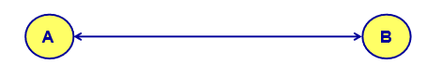

* Typically, a single hop is considered better
* But energy consumption wise, multi-hop is better for wireless communications:
  + Single hop: path-loss $∝\frac{1}{d^{α}}$
  + Multi-hop: path-loss $∝\frac{n}{{\left(\frac{d}{n}\right)}^{α}}$

**Simple routing solutions**

* **Broadcast**
* **Star topology –** send to parent
* **Tree topology –** send to parent or descendent, each parent needs to store information about children beneath it

**Routing in wireless mesh**

* Issues: Interference and self-interference
* Goal: Select route that **minimizes** **interference** and **error**

**Flooding –** mesh equivalent of a broadcast, include a TTL in packet header to ensure packet does not live in network forever.

**Reactive routing**

* Builds up a map of the routes through a network
* Map routes in reaction to packet arrival

**Ad-hoc On-demand Distance Vector Routing (AODV)**

* Routing table
  + Contain (Destination node, next hop) mappings
  + Store only next hop instead of full route
  + All routers along path must also have the mapping
  + Also keep hops-to-destination and last-seen-destination-seq-number
* Routing discovery
  + Check table, if not cached, send route request (**RREQ**) via flooding

**AODV RREQ**



* Request ID identifies this RREQ – discard duplicates during flooding
* Sequence numbers are per-device, monotonically increasing
* Hop count is the number of hops this request has taken. Starts at 1 and incremented by each transmitter along the path.

**AODV Route Response (RREP)**

* Reply is sent unicast back to the source via newly constructed route
* Includes most recent destination sequence number as a sense of recency

**Tradeoffs for reactive routing**

* **Pros:** No transmission unless there is demand
* **Cons:**
  + Expensive RREQ/RREP protocol before data can be sent
  + Route might be broken at some point, triggering RREQ/RREP process again

**Proactive Routing**

* Alternative is to learn the routes ahead of time
* Periodically query for the possible routes in the network and save all important routes
* Redetermine route when network topology changes
* Pros: Route is already known when packet arrives
* Cons: Wastes some network bandwidth on checking for route changes

**Mobile Wireless nodes: Ad-hoc wireless routing**

* What if the nodes are not static but mobile?
* No infrastructure exists in a Mobile Ad-hoc Network
* The network’s wireless technology may change dynamically in an unpredictable manner since nodes are free to move and each node has limited transmitting power

**Delay Tolerant Networks**

* Nodes are mostly disconnected.
* Range is short and mobile nodes meet each other **opportunistically**
* To improve delivery ratio, messages are typically duplicated to many nodes
* Possible constraints: Need to buffer message, and short duration of opportunistic contact

**Routing Protocol for Low-Power and Lossy Networks (RPL)**

* Considered a distance-routing and source routing protocol

**Low Power Wide Area Networks (common qualities)**

* Unlicensed 915 MHz band (902 – 928 MHz)
* Higher Power transmissions: ~20 dBm (100 mW)
* Low data rate of 100kbps or less
* Few kilometers range
* Simple ALOHA access control
* MAC choices for lower power
  + Make use of multi-hop to relay information
  + Devices should be off whenever possible – listen-after send for downlink
  + Remove requirement for synchronization (ALOHA over TDMA/CSMA)
    - Long range CSMA is problematic because detection of channel use is less reliable, and hidden terminal problem has a wider range

**LoRea Backscatter**

* Long range, low power, low-cost backscatter architecture
* Long range achieved through increasing receiver sensitivity by lowering bandwidth 🡪 Lower bandwidth, less noise in signal, better SNR, better sensitivity
* Operating frequency:
  + 868 MHz – 13 kHz bandwidth
  + 2.4 GHz – 180 kHz bandwidth

**LoRaWAN/ LoRA**

* **Characteristics**
  + Operates in unlicensed band (902 – 928 MHz)
  + Open communication standard built with proprietary LoRa PHY
  + Low data rate (1-20 kbps)
  + Long Range (~5km)
* Utilises Chirp Spread Spectrum
  + Modulation technique where frequency is varied linearly from lowest to highest within a channel. Data is modulated in the starting and ending points of chirp
  + Allows for different transmitters to transmit orthogonally on the same frequency.
  + Spreading factor to enable orthogonality
    - Rate of change of frequency
    - Lower Spread Factor = steeper slope = faster data rate

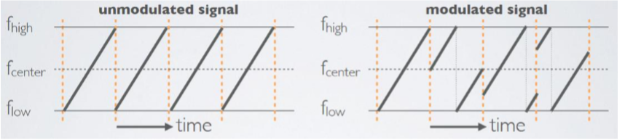

* Channel Allocation
  + 64 x 125 kHz uplink channels
  + 8 x 500 kHz overlapping uplink channels
  + 8 x 500 kHz downlink channels
* Data Rate – varies with channel and spreading factor

* See JunHong notes for LoRaWAN MAC
* LoRaWan packet format

* LoRaWAN providers
  + Helium and The Things Network
* Link budget and transmission range
  + See Junhong notes

**SIGFOX – see Junhong**

**TV Whitespace**

Using TV whitespace for communication:

**Pros:**

* Better propagation characteristics due to operating at lower frequency bands
* Less interference from other wireless devices
* More bandwidth available than typical sub-GHz frequency bands

**Cons**:

* Not available in every part of the world. Authorities will need to allow unlicensed use.
* Within the same country, the specific frequency may vary from region to region
* Need specialized hardware like software-defined radios. Commodity radio chipsets may not be designed to operate in TV spectrum

**Bluetooth** – also see junhong

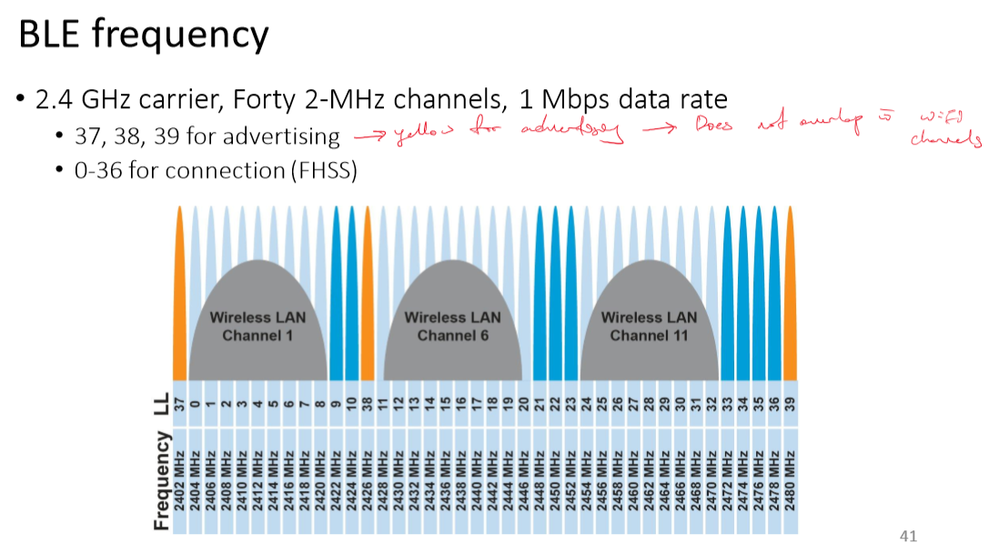

**BLE SCANNING**

**BLE CONNECTION MODE**

**Changes in BLE 5**

**Revised processing path for BLE5**

**802.15.4**

**Goals**

* Explicit support for low-cost, low-power, low-throughput devices
* Focus on low complexity for specification (only PHY and MAC are part of the specification)
* Primarily targets home automation, secondary use would be industrial control/monitoring, vehicular sensing and agricultural uses

**Physical Layer**

* 250kbps, ~100m range. Radio hardware available with low power and cost
* 27 channels over 3 frequency bands, w **different regional availability and rules**
  + 868.0-868.6 MHz (Available in Europe) (1% duty cycle)
  + 902.0-928.0 MHz (Available in Americas) (400ms dwell time)
  + 2400-2483.5 MHz (Available worldwide)
* 5 MHz channel separation at 2.4 GHz

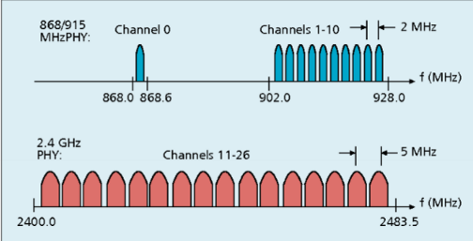

**Different Topologies**

802.15.4 specifies only PHY and MAC, but has different use cases in mind

* **Star network, Tree network**
  + PAN coordinator – receives and relays all message, most capable and power intensive
  + Coordinators (aka Routers) – control “clusters”, receives and relays to its children, communicates up to parent coordinator
  + End devices – only communicate with single parent coordinator. Least capable and power intensive

* **Peer-to-Peer/Mesh network**
  + Most devices capable of communicating with multiple neighbors
  + **Pros**
    - Less single points of failure, device failure less likely to collapse network
    - Devices can communicate over longer distances with more hops
  + **Cons**
    - Some nodes have to spend more energy communicating
    - Network protocol becomes more complicated to manage routing

**Modes of operation for PAN**

* **Beacon enabled PAN**
  + Slotted CSMA/CA
  + Structured communication patterns
  + Optionally with some TDMA scheduled slots

* Beacons occur periodically (15ms-245s) – Devices must listen to each beacon
* Contention access period – Slotted CSMA/CA synchronized by beacon start time
* Inactive period – No communication occurring, assumes sleepy devices

* PAN coordinator creates a contention free period with guaranteed time slots
* TDMA schedule assigned to different devices
* GTS eat up part of the contention access period
* No CSMA/CA within a slot
* **Non beacon enabled PAN**
  + Removes beacon, and synchronization benefit, and beacon listening costs.
  + Unslotted CSMA/CA
  + No particular structure for communication – could be defined by other specs like Zigbee or Thread

**Slotted/Unslotted CSMA/CA operation**

* Have data to send
* Wait for next backoff slot (synchronized from beacon) (slotted)
* Wait for 0-7 backoff slots
* Listen (for two empty slots (slotted))
  + Idle: Transmit
  + Occupied, wait for 0-2i+1 backoff slots and repeat
    - Timeout if upper limit of $i$ is reached and still occupied for 2 more backoffs

**Thread**

Builds a networking layer on top of 802.15.4

* Reuses most of PHY and MAC
* Adds IP communication
* Handles addressing and mesh maintenance

**ZigBee- Wireless Personal-Area Network**

* Encompasses all things within the workspace of a person
* Conceptually smaller domain than Local Area Network
* Realistically about the same as a LAN
* Formerly included a Bluetooth specification until Bluetooth SIG took over governance.

Reuse all of PHY

Reuse all of MAC

Zigbee Coordinator

Zigbee Router

Zigbee end device

Older zigbee – tree networks

Original Preferred Topology

Now: Mesh

**Wifi**

* Covers small area (approx. 10-30m), very high throughput
* Star topology, which forms Basic service set
  + Access points
  + Multiple connected clients
* Service set ID
  + Identifies network
  + Broadcast by access point in beacons